Divergent Thinking in the Grasslands:
Thinking about object function in the context of a grassland survival scenario elicits more alternate uses than control scenarios

Stuart Wilson
Memory Research Lab
Division of Psychology and Sociology
Queen Margaret University
Edinburgh
UK
EH21 6UU
swilson@qmu.ac.uk
Running head: Divergent thinking in the grasslands
(This is an Accepted Manuscript of an article published by Taylor & Francis in The Journal of Cognitive Psychology)
Acknowledgements: Thanks to Hope Christie, Stella Wilde, Karl Johnson, Aysel Denli and Tuntiak Karakras Murray and Matthew Gibson for help with data collection and coding.

Abstract
The survival processing effect is a recall advantage for information processed in the context of a grassland survival scenario. The current studies build upon previous research suggesting the effect is due to elaborative encoding and functional thinking. In two experiments participants completed the “alternate uses test” under five conditions: baseline, grassland survival, Ebola survival, moving to a new home & planning a bank heist. Experiment 1 stimuli were everyday objects. Experiment 2 stimuli were functionally ambiguous “mystery” objects. Number of generated uses was highest in the baseline, but the grasslands scenario was consistently highest of the schematic conditions. Recall data lend support to the mnemonic superiority of the grasslands condition. Results suggest that grassland scenarios place fewer attenuating constraints on divergent thinking. It is suggested that the survival processing effect might be usefully conceptualised as an effect of creatively thinking about object function in response to broadly defined problems.

Keywords: Adaptive memory; survival processing; divergent thinking; elaborative encoding; processing schema; creativity; contextual cognition; problem solving

The survival processing effect was introduced into the memory literature in 2007 by Nairne, Thompson & Pandeirada. They found that asking participants to rate words for relevance to being “stranded in the grasslands of a foreign land, without basic survival materials” led to superior recall for those words in a subsequent surprise memory test. Since Nairne et al’s initial papers (2007a, 2007b) a number of other studies have confirmed the robustness of the effect and have attempted to extend and explain the findings (see Schwartz, Howe, Toglia & Otgaar, 2014). This has led to a number of investigations into what proximate cognitive mechanisms might be implicated in driving the effect (see, e.g. Burns, Burns & Hwang, 2011; Erdfelder & Kroneisen, 2014).
One explanation that has attracted attention concerns how richly the stimulus materials are encoded when processed. Kroneisen & Erdfelder (2011) suggest that “it is not the evolutionary significance of survival per se that explains the survival processing effect. Rather, the degree to which survival processing invites elaborative, distinctive forms of encoding would predict the mnemonic benefit” (p. 1554). Kroneisen & Erdfelder (2011) report data suggesting that the effect relies on participants being free to generate a rich set of ideas relating to the stimulus materials (see also Kroneisen, Erdfelder & Buchner, 2013; Otgaar, Jelicic & Smeets, 2015).
Röer, Bell & Buchner (2013) extended the elaborative encoding account, reporting that the grassland survival scenario causes participants to generate a greater number of potential uses for the study items than is afforded by control scenarios. In a follow-up study, Bell, Röer & Buchner (2015) found that directing participants to think about the function of items during encoding was associated with significantly higher recall performance (a finding that has theoretical support; see Barsalou, Sloman & Chaigneau, 2005). In an attempt to address the question of why the grasslands scenario is particularly effective in activating this kind of processing, Bell et al (2015) emphasise the interaction between the novelty of the processing scenario and the functional thinking that it stimulates. They claim that “it is reasonable to assume that thinking about the object’s use in more everyday scenarios such as moving to another city is more restricted to the usual function of the object[s]” (p. 8) and go on to say that “the grasslands survival problem may stimulate more creative problem solving – and, by implication, more elaborate encoding – than everyday tasks such as moving” (p. 8). To support this, the authors report that participant-generated ideas obtained in their previous study (Röer et al, 2013) were rated as more creative when they were generated in the grassland condition. The current studies aim to further investigate this. Although Röer et al’s (2013) results suggest that creative thinking may be a contributing factor to the elaborative processing that underpins the survival processing effect, the way that they measured this was in the context of a standard survival processing task in which participants were presented with a list of words (ten words per condition in their experiment). Using multiple stimulus items is necessary when the primary hypothesis relates to recall for those items, but it serves as a potential source of noise when used as a measure of how the processing scenario itself influences creative thought. The current study aimed to achieve a purer measure of creative thinking. To achieve this, a standard test of divergent thinking was used: Guilford’s Alternate Uses Test (AUT; Guilford, 1967). The AUT requires people to generate as many alternate uses as they can for common objects within a limited time period. It has been validated in various ways (e.g. Gibson, Folley & Park, 2009) and is a widely used measure. Using the AUT in conjunction with the scenarios has the advantage of reducing any potential error that is associated with using multiple stimulus items as it measures divergent thinking in response to single objects only. Additionally, by its nature, the AUT encourages functional thinking, meaning that the key task demands are similar to those employed by Bell et al (2015) in the paper in which they argue that functional thinking is a key component of the survival processing effect.

Rationale
The standard AUT was used in the current experiments along with modified versions designed to incorporate scenarios similar to those used in survival processing research.
The operational definition of divergent thinking when measured by the AUT is the number of alternate uses provided for an object in the given time period. Anything that is likely to constrain the scope of divergent thinking will inevitably result in decreased performance (i.e. fewer alternate uses will be generated). The standard AUT places few constraints on participants’ responses, simply requesting of them to generate as many alternative uses for a given item as possible in the given time period.
In contrast, asking participants to generate uses in relation to a processing scenario should act as a constraint: there is a larger possibility space for uses generated in response to “think of as many functions for this object as you can” than there is for uses generated in response to “think of as many functions for this object as you can that relate to this scenario”. Thus, it is predicted that performance on the standard AUT, in which responses are completely unconstrained, will be higher than performance on the modified AUTs in which responses are constrained according to the scenario presented. However, if it is the case that the grassland scenario is somehow “special” in its ability to elicit divergent thinking, then performance in this condition should be significantly higher than in the other schematic conditions. Finally, the design allows for memory to be tested. Due to the fact that the current task is different to standard survival processing tasks, the surprise memory test employed in the current studies asked participants to recall the uses that they generated in response to the objects presented during the first part of the experiment. Because of the considerable differences in the task demands in this recall test compared to previous survival processing studies, no specific predictions were made with regards to memory performance and this measure should be considered to be exploratory in nature.
Experiment 1
In the first experiment, participants were asked to take part in five alternate uses tasks lasting three minutes per task, in which they had to generate responses for five common objects.
Participants
Fifty participants took part (nine male). Mean age = 20 (s.d. 5.5)
Design & Materials
A within-subjects design was used, with participants completing the AUT in five conditions. Dependent variables were total number of alternate uses generated and the number of those responses that were valid in the context of the scenario. Recall of the uses generated was an exploratory dependent variable.
Response booklets were created in which instructions were provided for each task. A booklet contained the five contexts in which participants were to undertake the AUT. These contexts were:
1 Unconstrained – standard version of the AUT. In this condition, participants are instructed simply to “write down as many different uses for the object as you can think of”
2 Grassland – this scenario reflects the standard grasslands condition that has repeatedly shown to induce a mnemonic advantage. It read: For this object, we would like you to imagine that you are stranded in the grasslands of a foreign land without any basic survival materials. Over the coming days and weeks, you will need to find steady supplies of food and water and protect yourself from predators. Please write down as many different uses as you can think of for the following object that apply to this scenario
3 Ebola – this scenario was similar to the grassland scenario in that it presents participants with an evolutionarily relevant threat (contagion avoidance) in a novel context. “Contagion avoidance” was chosen as an adaptively relevant problem that could be meaningfully contrasted with the problem presented by the standard grasslands condition (predator avoidance). It was decided that this would be a more appropriate comparator for the grasslands scenario than a “modern” survival scenario (e.g. the one used by Weinstein, Bugg & Roediger (2008) in which participants are asked to imagine being stranded in a city) because the objects that were to be used as stimulus items in the current study were primarily “modern” objects and this presents an inherent congruity problem that could act as a confounding factor (see, e.g. Butler, Kang & Roediger, 2009). Instead, it was decided that, in order to test whether the standard survival scenario is somehow unique in the processing that it encourages, it was deemed necessary to create a parallel scenario that was as similar to it as possible but while at the same time presenting participants with a different survival problem to the one that they would experience when presented with the grasslands condition. As such, a new scenario was created in which participants were still asked to imagine facing a novel survival threat in an unfamiliar environment, but in which the survival threat was distinctly different to the grasslands scenario. So, in place of “grasslands of a foreign land” the new scenario placed participants “in an African town” and instead of being asked to imagine having to find food, water and protection from predators the new scenario introduced an equally potent but fundamentally different kind of threat: avoiding potentially lethal contagion. This new scenario read: For this object, we would like you to imagine that you are stranded in an African town during an Ebola outbreak. You have been quarantined and will not be allowed to leave until the threat of infection has been deemed safe. Over the coming days and weeks you will need to ensure that you avoid becoming infected with the virus. Please write down as many different uses as you can think of for the following object that apply to this scenario
4 New Home – this scenario is a schematic control that has been previously used in survival processing studies (e.g. Nairne et al, 2007). It read: For this object, we would like you to imagine that you are planning to move to a new home in a foreign land. Over the coming days and weeks you will have to locate and purchase a new home and transport your belongings. Please write down as many different uses as you can think of for the following object that apply to this scenario
5 Bank Heist – this scenario reflects another schematic control condition that has been used previously (Kang, McDermott & Cohen, 2008). It read: For this object, we would like you to imagine that you are part of a team that is planning to rob a well-guarded bank. Over the coming days and weeks, you’ll need to make a plan and gather any supplies you might need. Please write down as many different uses as you can think of for the following object that apply to this scenario
With the exception of the baseline Standard AUT condition (which always appeared first) the order that the scenarios appeared in the response booklets was counterbalanced between the sample so that each scenario appeared in each position (2nd, 3rd, 4th or 5th) an equal number of times.
A slide presentation was created that presented the stimulus items in pictorial form. Stimulus items were presented along with their common use. The items were: A pencil (common use: to write with); a brick (common use: to build); a ball of string (common use: to tie things); a barrel (common use: to store liquid) and a rubber-tyre (common use: to cover a wheel)
A page of anagrams was also included in the response booklet to serve as a distractor task, and a blank sheet was included at the end to allow for responses to the surprise memory test.
Procedure
Testing was conducted in a classroom. Participants were requested to leave a gap of one seat between them and their nearest neighbour. The order in which the response booklets were administered to participants in the class was organised so that no two participants sitting next to each other received the same scenario at the same time (with the exception of the baseline condition, which everyone completed first). After reading information sheets and completing consent forms, the experimenter gave a short introduction including an example scenario in which alternate uses for a common object were given as example responses. The example scenario was of similar length to the scenarios to be used in the study and invited participants to imagine they were arranging the “holiday of a lifetime”. The example object was a newspaper (common use: to read) and several suggested alternate uses were provided. These were: to fashion into a paper boat to use in a swimming pool; to use as a temporary hat to protect oneself from the sun; to wrap sun-screen in for packing in suitcase; to line the bottom of a travel-bag; to use as an emergency diaper for an unwell friend or relative. After this, the main experiment began with each step in the process being displayed on the large classroom screen. During each AUT participants were given three minutes to write down as many different uses that they could think of for each item that was presented on the screen in accordance with the scenario that was outlined at the top of the page on which they were to respond.
Once all items had been presented, participants spent two minutes completing anagrams before being asked to write down on the final page as many of the uses that they had previously offered as they could remember, in any order they wished. They were given ten minutes to complete this task, after which they were thanked for their participation and debriefed.
Results & Discussion
Responses were rated by two independent raters who were blind to the hypotheses, and who scored responses on total number of alternate uses generated, and number of these that were valid given the scenario. Inter-rater reliability on all measures was high. For total number of responses, IRR was .97; for valid responses it was .82). Raters were also asked to score how many uses were successfully recalled in the recall task (IRR = .93).
Total Number of Uses
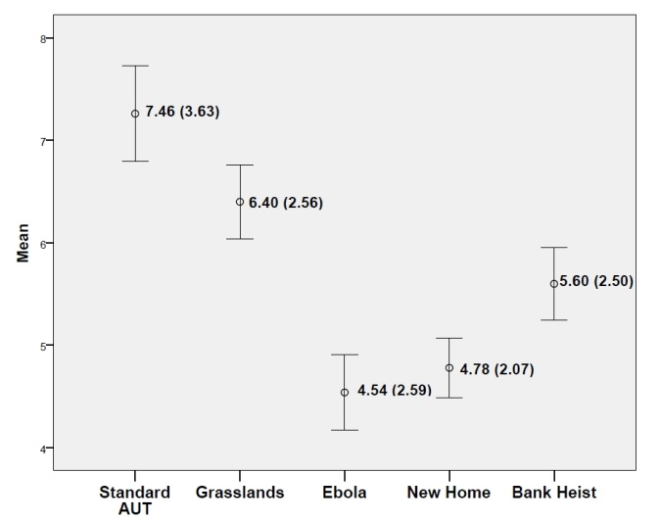
Figure 1: Mean Number of Responses per condition (error bars represent standard error of mean; figures represent mean values with standard deviation in brackets)
As can be seen in Figure 1, the Standard AUT (which is an unconstrained measure of divergent thinking) elicited more alternate uses for the objects than the other scenarios. The grasslands scenario also produced a high number of alternate uses. An ANOVA revealed a significant effect of condition F (4, 196) = 27.12, p < .001 = .36. Planned comparisons revealed that the total number of responses in the Standard AUT condition was significantly higher than all other conditions (see Table 1 for statistics). Responses in the grasslands condition were also significantly different to all other conditions (significantly lower than the Standard AUT condition, but significantly higher than the Ebola, new home and bank heist conditions; see Table 1 for statistics). These results are in line with what was predicted.
Standard AUT v | Grasslands | t (49) = 2.82. p < .01
 | Ebola | t (49) = 8.61 p < .001
 | New Home | t (49) = 6.45 p < .001
 | Bank heist | t (49) = 5.41 p < .001
Grasslands v | Ebola | t (49) = 6.48 p < .001
 | New Home | t (49) = 5.24 p < .001
 | Bank heist | t (49) = 2.89 p < .01
Table 1: Planned comparisons between Standard AUT/Grassland conditions and other conditions on the total number of uses generated per condition.

Valid Responses
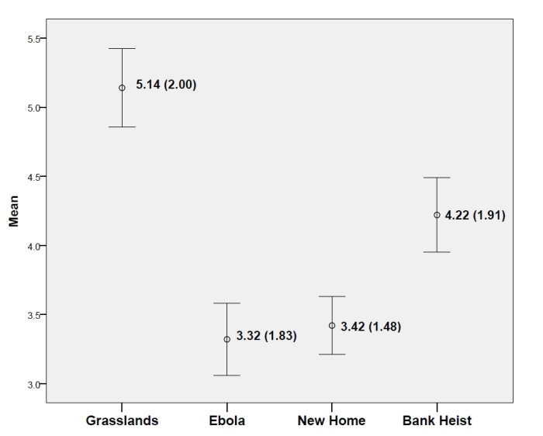
Figure 2: Mean Number of Valid Responses per condition (error bars represent standard error of mean; figures represent mean values with standard deviation in brackets)

Figure 2 suggests that the grasslands condition elicits more valid responses than any of the three other schematic conditions. A main effect of condition was observed; F (3, 147) = 17.51, p < .001= .26. Planned analyses confirmed that the grasslands condition elicited significantly more valid responses than all of the other schematic conditions (see Table 2 for statistics).
Grasslands v | Ebola | t (49) = 6.69 p < .001
 | New Home | t (49) = 5.79 p < .001
 | Bank heist | t (49) = 3.00 p = <.01
Table 2: Planned comparisons between grasslands condition and other schematic condition on “valid” responses
Table 3 shows the scores for each stimulus object categorised by schema condition. As can be seen from the table, the grassland divergent thinking advantage was evident for all stimulus objects.
 |  | Grasslands | Ebola | New Home | Bank Heist
Brick | Total | 6.43 (2.79) | 3.92 (1.89) | 4.67 (1.44) | 5.42 (1.93)
Brick | Valid | 5.00 (1.57) | 2.67 (1.61) | 3.50 (0.90) | 4.50 (1.38)
Brick | N | 14 | 12 | 12 | 12
String | Total | 5.58 (2.08) | 4.31 (1.38) | 4.62 (2.50) | 5.25 (3.60)
String | Valid | 4.50 (1.89) | 3.69 (1.03) | 3.61 (1.50) | 3.92 (2.71)
String | N | 12 | 13 | 13 | 12
Tyre | Total | 6.58 (2.84) | 4.84 (3.83) | 4.39 (1.85) | 5.33 (2.19)
Tyre | Valid | 5.42 (2.84) | 3.38 (2.69) | 2.85 (1.41) | 3.67 (1.87)
Tyre |  | 12 | 13 | 13 | 12
Barrel | Total | 7.00 (2.55) | 5.08 (2.71) | 5.50 (2.39) | 6.29 (2.16)
Barrel | Valid | 5.67 (1.56) | 3.50 (1.62) | 3.75 (1.96) | 4.71 (1.49)
Barrel | N | 12 | 12 | 12 | 14

Table 3: AUT scores (total and valid) for stimulus objects per schematic condition. Figures represent mean values with standard deviations in brackets.

Recall
As discussed previously, recall was necessarily an exploratory measure due to the significant disparity in the task demands of the current recall task compared to that employed in the survival processing paradigm. The recall data are presented here in two forms; proportional and absolute. The proportional score is the total number of correctly recalled uses divided by the overall number of uses that were generated in the corresponding condition during the initial stage of the experiment. The absolute score is simply the total number of generated uses that were correctly recalled.
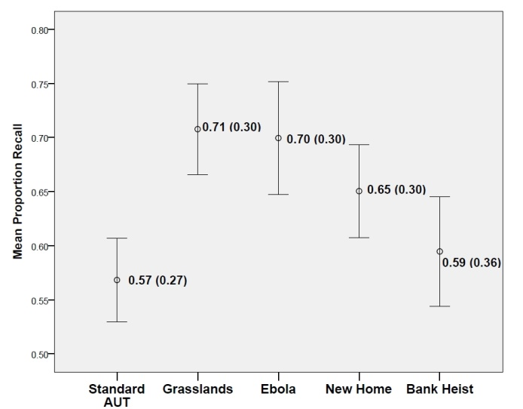
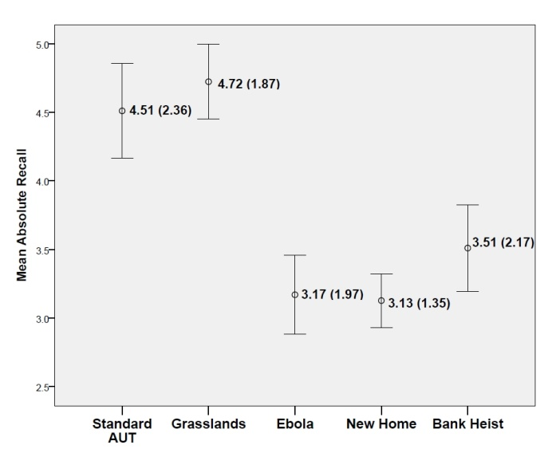
Figures 3a (top) and 3b (bottom): Figure 3a shows mean proportion of generated uses recalled. Figure 3b shows mean recall as an absolute value. Error bars represent standard error of the mean. Figures represent mean values with standard deviations in brackets.
Figure 3a reveals that the proportional recall rate for uses generated in the Standard AUT condition is lowest, whereas the proportional recall rate for uses generated in the grasslands condition is highest. An ANOVA revealed a significant effect of condition: F (4, 196) = 3.27, p = .01, = .06. Post hoc tests revealed that the proportion of generated uses recalled in the Standard AUT condition was significantly poorer than in both the grasslands and Ebola conditions. Comparison with the new home condition fell just short of significance (see Table 4 for stats). When the grasslands condition is compared to the other scenario conditions on this measure, the only one that it is significantly different to is the bank heist condition.

Standard AUT v | Grasslands | t (49) = 4.14. p < .001
 | Ebola | t (49) = 2.40 p = .02
 | New Home | t (49) = 1.95 p = .06
 | Bank heist | t (49) = .62 p = .54
Grasslands v | Ebola | t (49) = .16 p = .87
 | New Home | t (49) = 1.56 p = .12
 | Bank heist | t (49) = 2.22 p = .03
Table 4: Comparisons of recall-proportion scores per condition.

When the absolute scores are considered, a main effect for condition is evident: F (4, 184) = 12.12, p < .001, = .21. Comparisons are displayed in table 5.

Standard AUT v | Grasslands | t (49) = 0.61. p = .55
 | Ebola | t (49) = 3.71 p = .001
 | New Home | t (49) = 4.14 p < .001
 | Bank heist | t (49) = 2.76 p = .008
Grasslands v | Ebola | t (49) = 6.39 p < .001
 | New Home | t (49) = 7.76 p < .001
 | Bank heist | t (49) = 3.64 p = .001
Table 5: Comparisons on absolute recall scores
Interpreting the absolute recall results is not straightforward, as one might expect conditions in which more uses were generated in the first phase of the experiment to be associated with higher recall in the final phase. However, there are some things worth noting. Firstly, taken at face-value, it does appear that participants are indeed remembering more of the uses for the objects that they had thought of in response to the grasslands condition compared to the other schematic conditions. However, we also see high absolute recall rates for the standard AUT condition.
When we consider the recall data along with the data from the AUT, this provides further evidence that the grasslands scenario might be associated with a mnemonic benefit. The two conditions in which most uses were generated in the first part of the experiment were the Standard AUT and the grasslands condition, both of which elicited significantly more uses for the objects than the other schematic conditions. However, when participants are asked to recall the uses that they generated the proportion recalled in the Standard AUT condition is 57%, whereas in the grasslands condition the proportion recalled is 71% (see figure 3a); a highly significant difference. The relatively high proportion of recall seen in the schematic conditions suggests a general benefit of schema on recall, but the fact that the grasslands condition elicited significantly more uses than the other conditions but yet was still proportionately the highest level of recall is indicative of a mnemonic benefit associated with that condition. The fact that the Standard AUT condition was not associated with proportionally similar recall scores suggests that recall was not merely a function of the absolute number of uses generated in the initial task (otherwise we would have seen similar levels of proportional recall in the Standard AUT and grasslands condition, which we do not). Proportionally, recall in the other schematic conditions was lower than in the grasslands condition, despite there being significantly fewer things to recall in each of these conditions compared to the grasslands condition. As such, although the recall results are “messy”, it could still be argued that they do show evidence of the survival processing advantage.

Generally, the results of Experiment 1 were as predicted. It was predicted that divergent thinking, as measured by the Alternate Uses Test, would be most evident when undertaken in an unconstrained manner (i.e. the Standard AUT) compared to when undertaken according to the constraints imposed by structured processing schema. This prediction was supported. It was also predicted that, if the grasslands schema does indeed elicit the kind of divergent thinking that subsequently drives the survival processing effect, then the number of alternate uses generated in response to this scenario would be higher than the number generated in other schematic scenarios. This prediction was also supported for both dependent variables.
There are, however, two important methodological concerns that must be addressed before any strong conclusions can be reached about the role of divergent thinking in the survival processing effect. The first is that the baseline condition in Experiment 1 was always presented first and was therefore always presented alongside the same item (the pencil). The reason for this was because it was thought the baseline condition (which was the standard version of the AUT in which no scenario was presented) could act as an orienting condition that allowed participants to become familiar with the task before being asked to perform the task under more demanding conditions (i.e. in response to a specific scenario). This, however, leaves open the possibility that the results are confounded by the stimulus object, because all responses in the control condition were to the same stimulus. This issue is resolved in Experiment 2 by fully randomising and counterbalancing the order of the conditions, including the Standard AUT control condition. A second concern involves the potential for congruity between the stimulus objects and the processing scenarios. Although the allocation of scenario to object was randomised and counterbalanced in Experiment 1, it could still be possible that congruence between one particular scenario and one or more of the stimulus items is what caused the effect. If this was the case it would undermine the suggestion that divergent thinking is an important component of the survival processing effect, because a more parsimonious explanation might be that the congruence between stimulus item(s) and scenario(s) allows more ideas to be accessed from long term memory. This issue is addressed in Experiment 2 by using new stimulus materials that are not expected to differ in terms of how congruent or incongruent they might be perceived by participants with respect to the processing scenarios.

Experiment 2
Participants
Thirty-two participants took part (six male). Mean age = 22 (s.d. 11.4). Of these thirty-two, five participants were excluded due to them stating awareness of the function of one or more stimulus items (see below for description of stimulus items). The final analysis was performed on the remaining twenty-seven participants.

Design & Materials
The same experimental design as Experiment 1 was employed, with participants completing the AUT in five conditions. Dependent variables were total number of alternate uses generated and the number of those responses that were valid in the context of the scenario. Recall was again an exploratory measure.
To minimise the possibility that congruency between items and scenarios might be implicated in the effectand in order to replicate the previous effect with different stimuli, Experiment 2 used a new series of objects as stimuli. The stimulus items used for Experiment 2 were obtained from various “mystery object” websites. These are sites where pictures of unusual/mysterious/unidentified/ambiguous objects are uploaded and (in some cases) discussed. Objects were chosen that were of a size that made them easily held in the hands, but which did not have an immediately obvious function. As the common defining attribute of these objects is that nobody knows what they are, they are hard to describe, but the objects can be characterised as follows (objects are shown in Appendix 1):
Object1: this object resembled a pair of scissors, but instead of two cutting-edges were two hemispheres that looked about large enough to fit a golf-ball in when in the “closed” position. There was a small hole about ½ inch in diameter at the top of each hemisphere. They looked as if they were made from black iron and the outer casing of the hemispheres was patterned.
Object 2: this object looked like a cross between a knuckle-duster and a potato-masher. It had a straight, cylindrical wooden handle that could easily be grasped in one hand and protruding in front of the handle was a curved grill that connects to either side of the handle. It looked as if it could perhaps be used to mash potatoes or to slice vegetables (if the blades were sharper). The only thing that could said for certain about its function is that it is clearly a hand-tool. Object 3: This object is best described as looking like an ancient table-tennis paddle. It had an ornate wooden handle that can be held in one hand. At the top of the handle, just before it joins with the “paddle” section, it forms a curved “wrist-guard”. The paddle section is green and looks as if it could be made out of animal hide. It is unclear how flat this section is given the angle of the photograph, but it doesn’t look as if it is as solidly flat as one might expect from an actual table-tennis paddle.
Object 4: This was a small wooden object that had ten metal “spikes” protruding from its base. The wooden base looked approximately 1.5 inches in length and was rounded at one end and flat at the other. At the flat end, ten metal spikes protruded unevenly. These did not look as sharp as might be suggested by the word “spikes” and may be described as resembling metal versions of the “teeth” found on plastic hair-brushes, although the object was too small and the wrong shape to be easily classified as a brush.
Object 5: this object consisted of three “legs” held together by a central screw. Each leg was about 6 inches in length and formed an “L” shape. On each leg were two v-shaped indentations.
Response booklets were again created in which instructions were provided for each task. A booklet contained five contexts in which participants were to undertake the AUT. The order in which the contexts were presented within each booklet was randomised. The response booklets were identical to those used in Experiment 1 with the following exceptions. In these booklets, numbers were printed down the left-hand side of the response page, underneath the processing instructions. Participants were asked to use these to number their responses. There were ten spaces for responses in total, with an instruction after the tenth that the back of the page could be used if the participant came up with more than ten (nobody did). For the recall task, the page was split into five sections, and a photo of each of the objects presented during the experiment was shown in each section. Participants were told to write down as many uses as they could remember generating for each object in the box next to its image. The final page of the response book consisted of a picture of each object and asked participants to indicate whether or not they knew what the object was normally used for.
Procedure
As in Experiment 1, testing was conducted in a classroom setting. Participants were requested to leave a gap of one seat between them and their nearest neighbour. The order in which the response booklets were administered to participants in the class was organised so that no two participants sitting next to each other received the same scenario at the same time. After reading information sheets and completing consent forms, the experimenter gave a short introduction including an example scenario in which alternate uses for a common object were given as example responses. As in the previous experiment, the example scenario was of similar length to the scenarios to be used in the study and invited participants to imagine they were arranging the “holiday of a lifetime”. The example object comprised of a wooden handle and metal frame. The part of the metal frame that was attached to the handle formed a “Y” shape and attached to this was another frame that formed an elongated oval shape. The example uses provided were: To use to create bubbles to keep children entertained; to cook meat on by holding it over a fire in a makeshift barbeque; to use as a way to hang belts & ties in your wardrobe; to put in the sand to mark your location when you go swimming; to attach a net to as an improvised fishing device; to use as a handle for a child’s “water-ski” game
After this, the main experiment began with each step in the process being displayed on the large classroom screen. During each AUT participants were given three minutes to write down as many different uses that they could think of for each item that was presented on the screen in accordance with the scenario that was outlined at the top of the page on which they were to respond. Once all items had been presented, participants spent two minutes completing anagrams before being asked to write down on the final page as many of the uses that they had previously offered as they could remember, with each response being placed in the box next to the object that it was generated in response to. They were given ten minutes to complete this task, after which they were thanked for their participation and debriefed.
Results and Discussion
As before, responses were rated by two independent raters who were blind to the hypotheses, and who scored responses on total number of alternate uses generated, number of these that were valid given the scenario and number of responses recalled. Inter-rater reliability for all measures fell between .8 and 1.00
Total Number of Uses
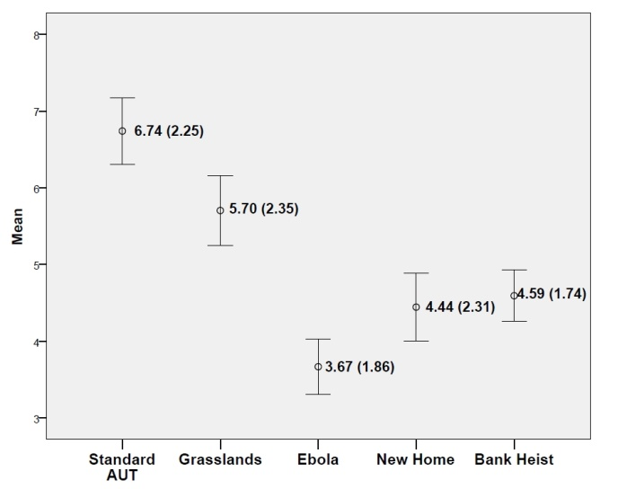
Figure 4: Mean number of responses per condition (error bars represent standard error of the mean; figures represent mean values with standard deviation in brackets)
As can be seen from Figure 4, the pattern of results in the current study is largely similar to that observed in Experiment 1. An ANOVA revealed a significant effect of condition; F (4, 104) = 15.78, p < .001, = .38.
Planned comparisons revealed that the total number of responses in the Standard AUT condition was significantly higher than all other conditions (see Table 6 for statistics). The total number of responses in the grasslands condition was also significantly different to all other conditions (significantly lower than the Standard AUT condition, but significantly higher than the Ebola, new home and bank heist conditions; see Table 6 for statistics). These results are in line with what was predicted and are strikingly similar to the results from the previous experiment.
Standard AUT v | Grasslands | t (26) = 2.18. p = .04
 | Ebola | t (26) = 8.90 p < .001
 | New Home | t (26) = 5.61 p < .001
 | Bank heist | t (26) = 4.06 p < .001
Grasslands v | Ebola | t (26) = 4.65 p < .001
 | New Home | t (26) = 2.44 p = .022
 | Bank heist | t (26) = 2.68 p < .013
Table 6: Planned comparisons between Standard AUT/Grassland conditions and other conditions on the total number of uses generated per condition.

Valid Responses
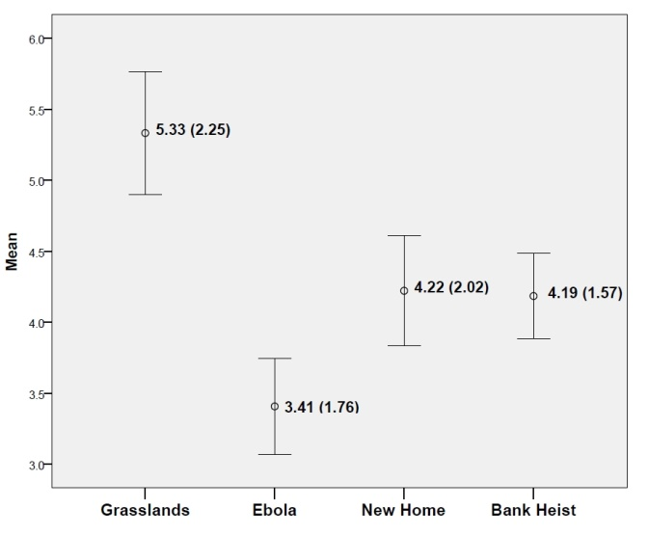
Figure 5: Mean Number of Valid Responses per condition (error bars represent standard error of mean; figures represent mean values with standard deviation in brackets)

Figure 5 suggests that Experiment 2 largely replicated the results of Experiment 1. A main effect of condition was observed; F (3, 78) = 7.54, p < .001= .23. Planned analyses confirmed that the grasslands condition elicited significantly more valid responses than all of the other schematic conditions (see Table 7 for statistics).
Grasslands v | Ebola | t (26) = 4.83 p < .001
 | New Home | t (26) = 2.16 p = .04
 | Bank heist | t (26) = 3.22 p = <.01
Table 7: Planned comparisons between grasslands condition and other schematic condition on “valid” responses
The scores associated with each individual stimulus object per schema condition are presented in table 8 below. These figures should be treated with caution because the nature of the randomisation in the current experiment meant that the data are based on relatively small Ns in each cell. Keeping this in mind, it can be seen that the grasslands condition is associated with generally higher levels of divergent thinking, except for object 1 (in which the New Home condition scores higher on both measures) and objects 2 & 5 (in which the Bank Heist condition scores higher).

 |  | Grasslands | Ebola | New Home | Bank Heist
Object1 | Total | 4.80 (1.48) | 3.75 (1.58) | 6.00 (1.26) | 4.25 (2.63)
Object1 | Valid | 4.40 (1.14) | 3.25 (1.28) | 5.67 (1.21) | 3.00 (0.82)
Object1 | N | 5 | 8 | 6 | 4
Object 2 | Total | 4.43 (1.99) | 4.14 (2.34) | NA* | 5.20 (1.48)
Object 2 | Valid | 4.14 (1.57) | 3.71 (2.29) | NA* | 4.80 (1.48)
Object 2 | N | 7 | 7 | 1* | 5
Object 3 | Total | 7.17 (2.32) | 3.33 (2.08) | 4.50 (1.76) | 4.50 (1.52)
Object 3 | Valid | 7.00 (2.53) | 3.33 (2.08) | 4.50 (1.76) | 4.33 (1.51)
Object 3 | N | 6 | 3 | 6 | 6
Object 4 | Total | 7.00 (2.65) | 4.25 (1.50) | 2.75 (1.49) | 3.00 (0.63)
Object 4 | Valid | 7.00 (2.65) | 4.25 (1.50) | 2.75 (1.49) | 2.83 (0.75)
Object 4 |  | 3 | 4 | 8 | 6
Object 5 | Total | 5.83 (2.71) | 2.60 (1.95) | 4.83 (3.43) | 6.00 (1.10)
Object 5 | Valid | 5.00 (2.28) | 2.60 (1.95) | 4.17 (2.64) | 5.67 (1.21)
Object 5 | N | 6 | 5 | 6 | 6
Table 8: AUT scores (total and valid) for objects per schematic condition. Figures represent mean values with standard deviations in brackets. Data relating to the Standard AUT condition are not presented in this table.
*No mean scores are available because, by coincidence, a number of the participants who were removed from this analysis saw Object 2 in this condition, leaving this cell with only one valid score.

Recall
As before, recall data are presented in two forms; proportional and absolute (see Figures 6a and 6b)
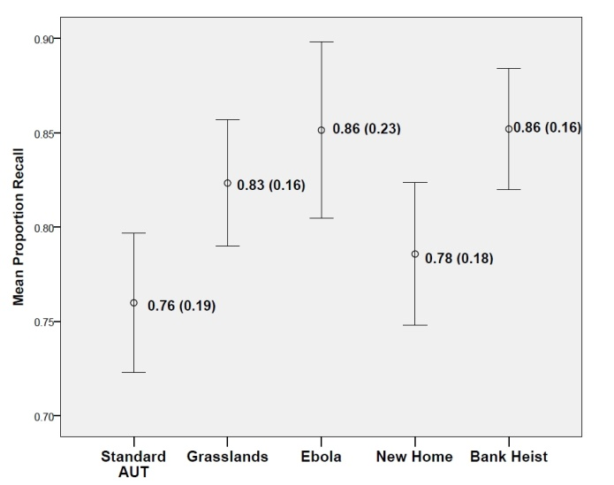
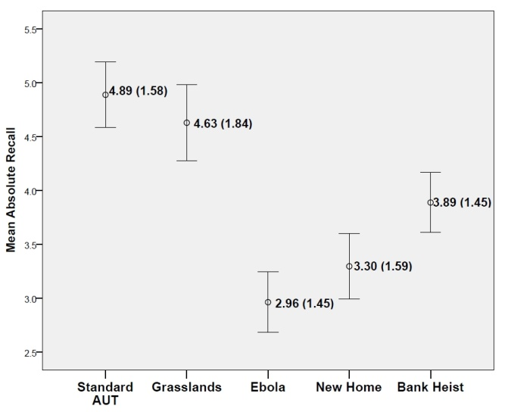
Figures 6a (top) and 6b (bottom): Figure 6a shows mean proportion of generated uses recalled. Figure 6b shows mean recall as an absolute value. Error bars represent standard error of mine, figures represent mean values with standard deviations in brackets
Figure 6a reveals that proportionate recall in the schematic conditions remained high, while the proportion recalled in the Standard AUT condition was notably higher than what was observed in Experiment 1. This likely reflects the changes in the methodology employed in Experiment 2, possibly due to the extra cognitive work involved in thinking of uses for an ambiguous object. An ANOVA revealed that there were no significant differences between any of the conditions for proportion recall. When absolute values are analysed a significant effect for condition is evident: F (4, 104) = 11.92, p = <.001= .31. Comparisons for absolute values are presented in Table 9

Standard AUT v | Grasslands | t (26) = 0.70. p = .49
 | Ebola | t (26) = 6.49 p < .001
 | New Home | t (26) = 5.03 p < .001
 | Bank heist | t (26) = 3.00 p = .006
Grasslands v | Ebola | t (26) = 4.71 p < .001
 | New Home | t (26) = 3.05 p = .005
 | Bank heist | t (26) = 2.47 p = .02
Table 9: Comparisons for absolute recall scores
Although these recall results don’t exactly replicate those from the previous experiment, they are notable in that the grasslands condition was again associated with both a high level of absolute and proportional recall. This, when combined with the observation that the grasslands scenario elicited more responses than any of the other schematic conditions, adds further support to the robustness of the survival processing effect, although the considerable differences between the current recall task and that used in the standard survival processing paradigm must be kept in mind when considering the current recall results.
General Discussion
Exactly why people recall things more efficiently after having rated them for relevance to a grassland survival scenario has been under debate since Nairne and his colleagues introduced the effect into the literature in 2007. The current experiments support the suggestion that the effect has its roots in the elaborative processes that the stimulus materials undergo at the encoding stage. The fact that the grasslands scenario elicited significantly more alternate uses compared to the new home and bank heist conditions in both experiments lends support to the assertion that divergent thinking, as afforded by that particular scenario, is likely to be a significant contributing factor to the elaborative processing required for the survival processing memory advantage. Furthermore, the current findings suggest that the elaboration responsible for the mnemonic effect is based in thinking about the function of the objects, with the survival scenario allowing for more divergent thinking in this respect than the control scenarios.
Bell et al (2015) propose what is essentially a two-part explanation for how functional thinking might explain the results observed in survival processing research. Firstly, they suggest that thinking about how objects might normally be used in the more “everyday” processing scenarios (such as moving home) leads to a form of “functional fixedness” which makes it difficult to subsequently think of alternate ways in which the items might be used. This inhibitive effect, according to Bell et al (2015), does not apply to the more novel scenarios (such as the grasslands) in which creatively thinking about function is almost mandated given the general lack of “normal” uses for the stimulus objects in such scenarios. Secondly, Bell et al (2015) suggest that the grasslands survival scenario might itself stimulate more creative problem solving than more mundane scenarios.
The experiments described in the current paper support the assertion that functional thinking is implicated in the survival processing effect. Completing the Alternate Uses Test requires functional thinking and the results from both experiments clearly demonstrate that the grasslands scenario elicits more functional responses than any of the other schematic conditions. However, the results from Experiment 2 challenge the first part of Bell et al’s (2015) explanation. Given that participants did not know the true function of the objects in Experiment 2, then it is not possible that they experienced functional fixedness during which a focus on the “normal” functions of the stimulus objects inhibited the generation of novel alternatives. Any potential congruity between the stimulus objects and the processing schemas was minimised in Experiment 2, with no detriment to the observed effects.

The results of Experiment 2 lend support to the second part of Bell et al’s explanation: that the grasslands scenario somehow stimulates more creative problem solving than the other schematic control conditions. However, a closer inspection of the data from both experiments suggests that this might not be the whole story. In both experiments the number of uses generated in the grasslands condition was not larger than the number produced in the unconstrained standard AUT condition, as would be expected if creativity was being somehow stimulated by the grasslands scenario. These findings suggest that creative/divergent thinking may not necessarily be stimulated by the grasslands scenario. Rather, a more likely explanation is that such thinking is less severely constrained by the grassland scenario compared to the other schematic conditions.
For example, the Ebola condition asked participants to imagine being quarantined in a town. This means that the scope of possible uses for objects in that scenario is arguably smaller than the scope of uses that is afforded by the grasslands scenario, which defines both the physical boundaries of the imagined scenario (“the grasslands of a foreign land”) and the problem at hand comparatively broadly (compare “find water and protect yourself from predators” to “avoid catching Ebola from anyone quarantined with you” as problems to be solved). The bank heist scenario is arguably even more constraining. Given that the divergent thinking process is reliant on broad access to disparate concepts in long-term memory, then one possible future direction is to investigate the relationship between the processing scenarios and access to existing long-term semantic representations.
The results from Experiment 2 suggest that the effect may not depend on access to representations in long-term memory that explicitly relate to the function of the stimulus objects (as the objects used in Experiment 2 were functionally ambiguous). Instead, it seems as though the grasslands scenario allows for more functions to be imagined for the items being rated, regardless of whether or not participants already have pre-conceived ideas of what each item is normally used for. This may lead one to consider the “problem” that the scenarios present and the degree to which solving the problem engages functional/divergent thinking processes. This is a question for future studies but it is possible that the problem that the grassland scenarios presents to participants (along with the other scenarios that have been shown to elicit elevated recall) represent a “Goldilocks” state in which all of the relevant features are “just right” for the effect to emerge. The relevant features are likely to relate to the nature of the “problem-space” in terms of how much it affords creative problem solving/functional thinking. Successful processing scenarios might be said to present “broad” problems, in that they are more open-ended with respect to what needs to be achieved to solve the problem compared to the more narrow problems that are presented in the control conditions (e.g. the bank heist). Additionally, successful scenarios might differ in terms of how much divergent/functional thinking is required to address the problem, with the grasslands problem inherently requiring high levels of creative tool-use, for example.
If this turns out to be the case then it changes the way that the survival processing effect can be characterised. Rather than being the “footprints” of an evolved mnemonic system that is tuned to certain ancestrally relevant contexts (Nairne et al, 2007), it might turn out to be the case that the effect is a consequence of our capacity to think creatively about how physical objects might be employed in service of a broadly defined problem. This, of course, would not mean that there is nothing “adaptive” about the survival processing effect. The ability to conceptualise novel uses for physical objects would have undoubtedly conferred an adaptive advantage to ancestral humans, as would abilities that contribute to finding creative ways to solve novel problems (in the short and long term). In fact, there is an argument to be made that being able to think about how one might use physical objects to manipulate the external environment in service of one’s needs is one of the core evolved characteristics of our species. Perhaps it is the processing involved in these evolved capacities that will ultimately turn out to be driving the survival processing memory advantage.
References
Barsalou, L., Sloman, S., & Chaigneau, S. (2005). The HIPE theory of function. In L. Carlson, & E. Van der Zee (Eds.), Representing functional features for language and space: Insights from perception, categorization and development (pp. 131–147). Oxford: Oxford University Press.
Bell, R., Röer, J.P. & Buchner, A. (2015) Adaptive Memory: Thinking about function. Journal of Experimental Psychology: Learning, Memory & Cognition, 41, 1038 – 1048 http://dx.doi.org/10.1037/xlm0000066
Bertsch S, Pesta BJ, Wiscott R, McDaniel MA (2007). The generation effect: A meta-analytic review. Memory and Cognition, 35(2), 201–210.
Burns, D. J., Burns, S. a, & Hwang, A. J. (2011). Adaptive memory: determining the proximate mechanisms responsible for the memorial advantages of survival processing. Journal of Experimental Psychology. Learning, Memory, and Cognition. doi:10.1037/a0021325
Butler, A.C., Kang, S.H.K., & Roediger, H.L. (2009) Congruity effects between materials and processing tasks in the survival processing paradigm. Journal of Experimental Psychology: Learning, Memory and Cognition, 35, 1477-1486. Doi:10.1037/a0017024
Erdfelder, E. & Kroneisen, M. (2014) Proximate cognitive mechanisms underlying the survival processing effect. In B.L. Schwartz, M.L. Howe, M.P Toglia & H. Otgaar (Eds.) What Is Adaptive About Adaptive Memory? (pp. 172-200) Oxford: Oxford University Press.
Gibson C, Folley BS, Park S (2009) Enhanced divergent thinking and creativity in musicians; a behavioral and near-infrared survival processing effectctroscopy study. Brain and Cognition, 69, 162-169
Guilford, J.P. (1967). The Nature of Human Intelligence. New York: McGraw-Hill.
Kang, S. H. K., McDermott, K. B., & Cohen, S. M. (2008). The mnemonic advantage of processing fitness-relevant information. Memory & Cognition, 36(6), 1151–6. doi:10.3758/MC.36.6.1151
Kostic, B., McFarlan, C.C. & Cleary, A.M. (2012) Extensions of the survival advantage in memory: Examining the role of ancestral context and implied social isolation. Journal of Experimental Psychology: Learning, Memory and Cognition, 38, 1091-1098.
Kroneisen, M., & Erdfelder, E. (2011) On the plasticity of the survival processing effect. Journal of Experimental Psychology. Learning, Memory, and Cognition. doi:10.1037/a0024493
Kroneisen, M., Erdfelder, E., & Buchner, A. (2013). The proximate memory mechanism underlying the survival-processing effect: Richness of encoding or interactive imagery? Memory (Hove, England), 21(4), 494–502. doi:10.1080/09658211.2012.741603
Nairne, J.S., Pandeirada, J.N.S., & Thompson, S.R. (2007a). Adaptive memory: The comparative value of survival processing. Psychological Science, 19, 176 – 180. doi: 10.1111/j.1467-9280.2008.02064.x

Nairne, J. S., Thompson, S. R., & Pandeirada, J. N. S. (2007b). Adaptive memory: Survival processing enhances retention. Journal of Experimental Psychology: Learning, Memory, and Cognition, 33(2), 263–273. doi:10.1037/0278-7393.33.2.263

Nairne, J., & Pandeirada, J. (2008). Adaptive memory: Is survival processing survival processing effectcial? Journal of Memory and Language, 59(3), 377–385. doi:10.1016/j.jml.2008.06.001

Nairne, J. S., & Pandeirada, J. N. S. (2010). Adaptive memory: ancestral priorities and the mnemonic value of survival processing. Cognitive Psychology, 61(1), 1–22. doi:10.1016/j.cogpsych.2010.01.005
Nairne, J.S. (2014) Adaptive memory: Controversies and future directions. In B.L. Schwartz, M.L. Howe, M.P Toglia & H. Otgaar (Eds.) What Is Adaptive About Adaptive Memory? (pp. 308-321) Oxford: Oxford University Press.
Otgaar, H., Howe, M.L. Smeets, T., Raymaekers, L., & van Beers, J. (2013). Memory errors in adaptive recollections. In B. Schwartz, M.L. Howe, M. Toglia, & H. Otgaar (Eds.). What is adaptive about adaptive memory? (pp 201-214). Oxford: Oxford University Press.
Otgaar, H., Jelicic, M. & Smeets, T. (2015) Adaptive memory: Identifying the proximate roots of the survival processing advantage. Journal of Psychology, 149 (4), 339-355 doi: 10.1080/00223980.2013.879848.
Röer, J. P., Bell, R., & Buchner, A. (2013). Is the survival processing memory advantage due to richness of encoding? Journal of Experimental Psychology: Learning, Memory, and Cognition, 39, 1294–1302. http://dx.doi.org/10.1037/a0031214
Schwartz, B.L., Howe, M.L., Toglia, M.P. & Otgaar, H. (2014). What Is Adaptive About Adaptive Memory? Oxford: OUP.
Weinstein, Y., Bugg., J.M., & Roediger, H.L. (2008) Can the survival recall advantage be explained by basic memory processes? Memory & Cognition, 26, 913-919. Doi: 10.3758/MC.36/5/913

APPENDIX
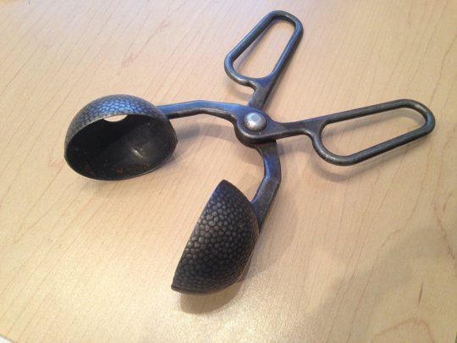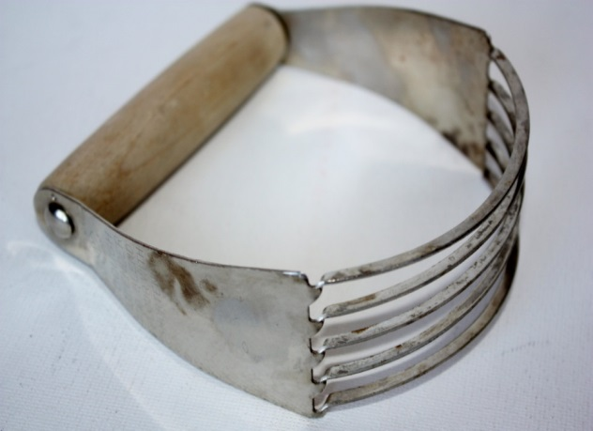
Object1 Object2
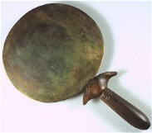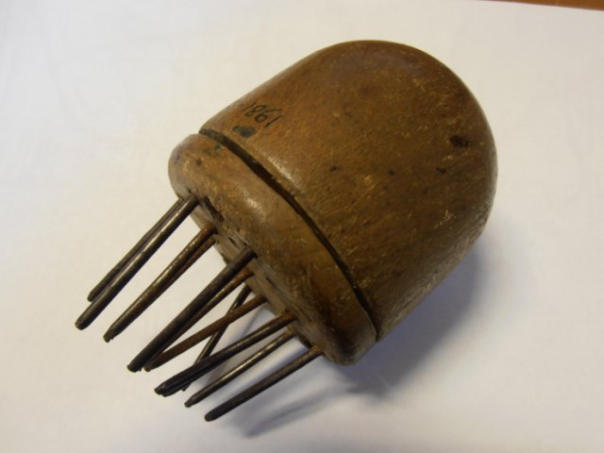
Object 3 Object 4
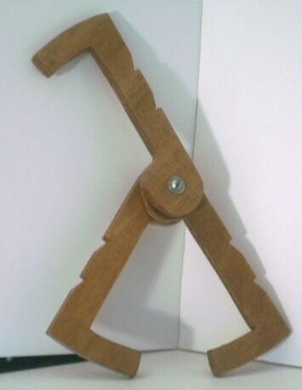
Object 5

Kang et al (2008) collected norming data comparing the grasslands and bank heist scenarios, and reported no difference between the two on how exciting they are perceived to be and on how novel they are perceived to be. Given that Bell et al (2015) suggest that novelty of scenario may influence the functional thinking that is primed by it, it was decided that the bank heist scenario would make an appropriate control condition. If the data suggest that the bank heist and grasslands conditions are quantitatively different in terms of the divergent thinking that they elicit, then it is unlikely that this could be explained by differences in novelty between the scenarios.
It was felt that it was important to distinguish total responses from valid responses in the scenario conditions because otherwise it would not be possible to determine responses that had been generated in response to the scenario itself and responses that had been generated for the object with no regard to the scenario constraints
These comparisons excluded the Standard AUT condition, as comparing what might be “valid” responses in this condition with “valid” responses in the other conditions would not make sense given that the Standard AUT specifies no scenario to which responses must be valid in relation to.
Note that memory for responses deemed invalid are included in this recall score. This was decided on the basis that, even although certain responses might be deemed invalid by the raters, all responses were generated as part of the same generation task and so should enjoy the same mnemonic benefit, should one exist.
As participants were instructed to write down uses in any order they wished, readers may be concerned about how we dealt with similar or identical responses that may have been generated in different conditions. Although this is a valid methodological concern and is addressed in experiment 2, neither rater experienced any instances in which a response could not be easily classified as belonging to a single condition.
It’s worth noting that proportion recall was not significantly correlated with total uses generated in any of the conditions, suggesting that any recall advantage is due to the schema itself being used as a way to structure recall rather than having anything to do with how many ideas were generated during the AUT.
This large standard deviation was caused by the inclusion of one participant aged 75. Without this participant, the mean age is 21 with a standard deviation of 6.44. There is no suggestion that this one participant performed any differently to the rest of the sample and so is not excluded from the analysis.
Although the stimuli in experiment 2 were essentially ambiguous, any participant who claimed to know the function of any of the objects was removed from the analysis so as not to confound any effect.
As in Experiment 1, this comparison excluded the Standard AUT condition and only compared the schematic conditions
Additionally, a further problem for any explanation that posits novelty as an important factor is that it must explain why the bank-heist scenario consistently fails to elicit a recall advantage despite it being rated as being equal in novelty to the grasslands scenario (Kang et al, 2008).

